**English Grade**

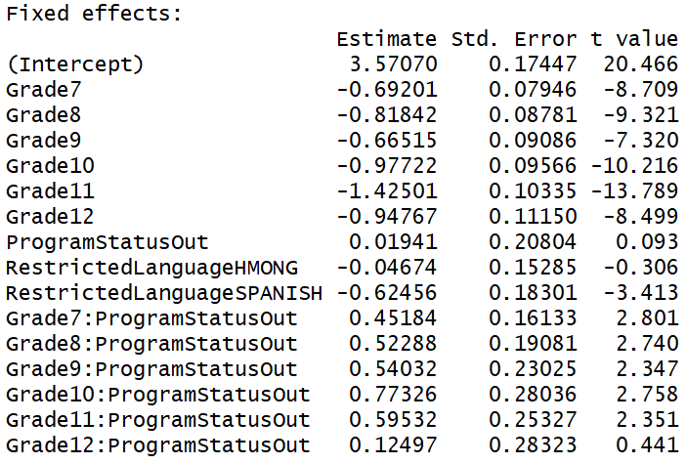

**Reading Grade**

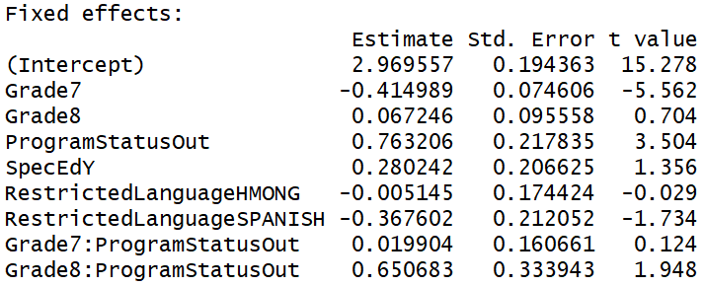

**Forward Exam**

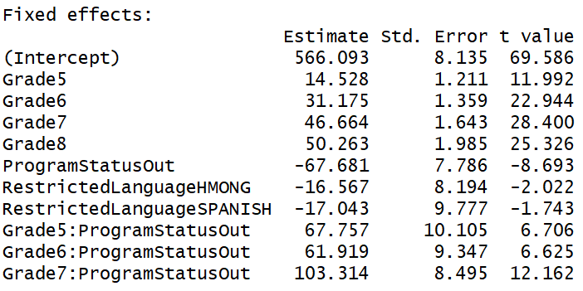

**MAP-Reading**

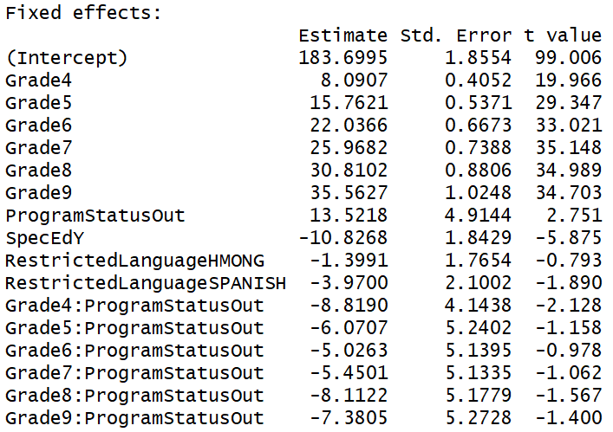

**MAP-Language**

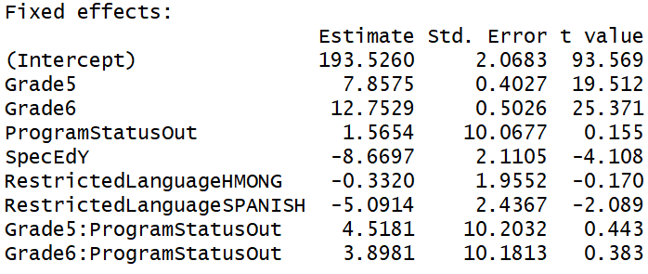

**Aspire-ELA**

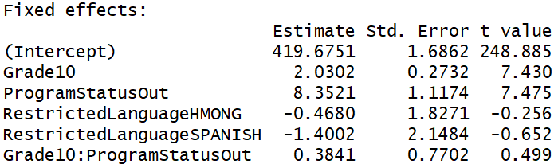

**Aspire-English**

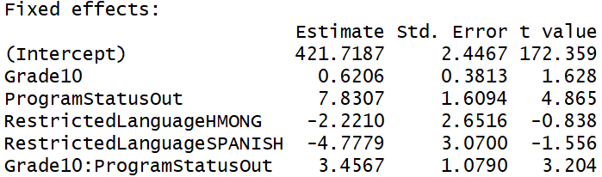

**Aspire-Reading**

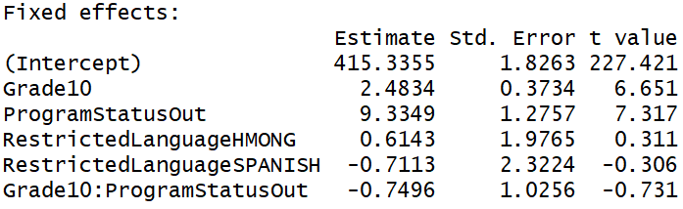

**Aspire-Writing**

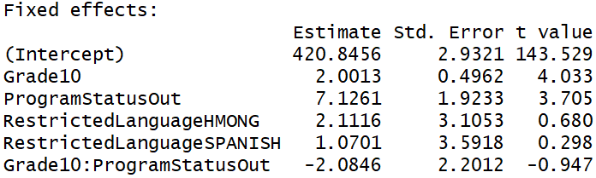

**ACT-ELA**

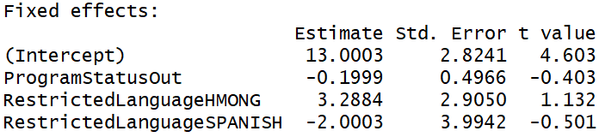

**ACT-English**

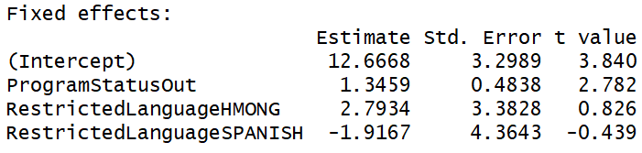

**ACT-Reading**

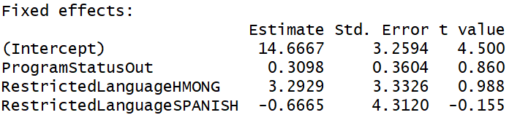

**ACT-Writing**

